Bangladesh University Of Business & Technology



LAB REPORT

Course Code : CSE-207

Course Title : Database Systems

Experiment Name : Create database & table, Insert data in table and solving the questions from the tables using xampp software.

Experiment No. : 03

Intake : 45

Section : 02

Program : B.sc. Engg in CSE

SUBMITTED BY : Shamsi Juma(068)

SUBMITTED TO : Zobaer Zihad (Lecturer, Department of CSE, BUBT)

1. Find the number of customers from all cities in “Customer” relation.

SELECT COUNT (customer_name) from customer_table;

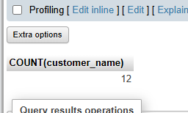

Q2.Find the total no. of loans from “Loan” relation from each branch.

SELECT COUNT(branch_name) as total_no_of_loans from loan_table GROUP BY branch_name;

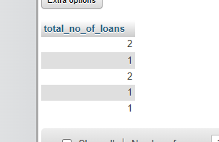

Q3. Find the total amount of loan from “Loan” relation of each branch which amount is greater than 1200.

SELECT branch_name,SUM(amount) As amount

FROM loan_table

GROUP By branch_name

Having amount>1200;

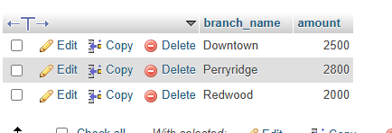

Q4. Find the average amount from each branch of “loan” relation.

SELECT AVG(amount)as average_amount FROM loan_table;

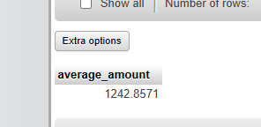

Q5. Find the total amount of each branch from “loan” relation.

SELECT branch_name,SUM(amount) As amount

FROM loan_table

GROUP BY branch_name;

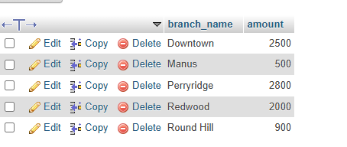

Q6. Find the total number of tuples for loan relation.

SELECT COUNT(*) As totaltuples from loan_table;



Q7. Retrieve the names of customers who have taken out loans from more than one branch.

SELECT borrow_table.customer_name,borrow_table.loan_number,loan_table.branch_name FROM borrow_table,loan_table WHERE borrow_table.loan_number = loan_table.loan_number GROUP BY customer_name HAVING COUNT(DISTINCT branch_name)>1;

